**Problem 2 - 2:4**

Please refer JAVA programs for Problem 2 to 2.4.

**Problem 2.5**

**Plot for Time taken by Standard Matrix Multiplication and Strassen Algorithm in Nanoseconds**

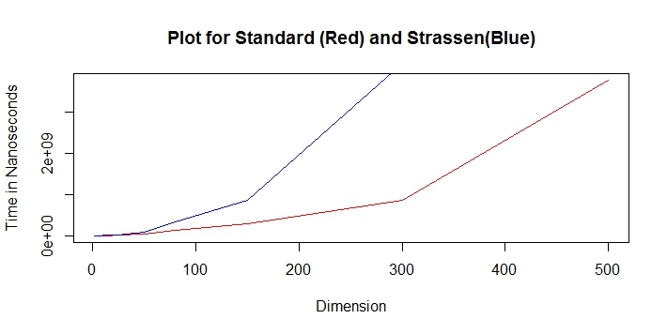

From Graph, We can say that Time taken for Standard and Strassen’s Algorithm is same when dimension is close to 40.

* Strassen takes less time for higher dimension when compared to Standard matrix multiplication.
* Time is more or less similar when dimension is between 0 to 50.

Strassen’s Algorithm can be improved by tuning i.e.:-

* Morton order that is based on a quad-tree decomposition of the matrix.
* select the recursion truncation point to minimize padding without affecting the performance of the algorithm.

Inefficiency of Strassen’s Algorithm

* when we encounter matrices with one or more dimensions of odd size.
* Strassen's construction is no longer advantageous when recursion truncation point is reached.

**List of References**

1. <http://www.sanfoundry.com/java-program-strassen-algorithm/>
2. <https://users.cs.duke.edu/~alvy/papers/sc98/>